College of Engineering

Department of Mechanical and Aerospace Engineering

MAE 208 (002)

Engineering Dynamics

Preliminary Report

Written By: Felipe Caicedo, Ashley Crickard, Cassie Kerr, Chloe Sanchez-Prado

Table of Contents
Introduction | 3
Design Concepts | 3
Linearly-Applied Force Design Concept | 3
Counterweight Catapult Launching Mechanism (Rotary Motion Design Concept) | 5
Expected Performance Calculations | 7
Advantages and Disadvantages of Design | 11
Summary | 12
Complete Calculations | 12
Calculations for Linearly-Applied Force Design Concept | 12
Calculations for Rotary Motion Design Concept | 14
Operation & Energy Transfer | 16
Material Cost & Receipts | 17
Testing Conclusions | 18
MATLAB Code | 20
Works Cited | 20
Thank You | 20

- Introduction
This course project serves as a culmination of our dynamics experience. The primary objective of this project is to design and build a mechanical system that accomplishes a specific function. This experience will expose us to a number of ever-present aspects in engineering design including: designing with specific constraints in mind, meeting performance objectives, understanding the important difference between theoretical and actual performance, and working in a team environment. This project is intended to go beyond the typical analysis-intensive nature of our dynamics education and understand the experimental nature of engineering projects.

The following requirements must be met:
- Size limit of 3 ft x 3 ft x 3 ft
- Launch the projectile (ie. tennis ball) 3 ft, 6 ft, 9 ft, 12 ft, and 15 ft
- Only one human input is allowed, and this input must be used to start the machine
- Total estimated cost of all materials must be no more than $25
- The machine must operate in a safe manner at the discretion of the judges

- Design Concepts
During our brainstorming process we decided on two designs: a design based on a linear spring launching mechanism (ie spring and wood) and a design based on a catapult launching (ie rotating arm) mechanism.

Linearly-Applied Force Design Concept (ie spring and wood)

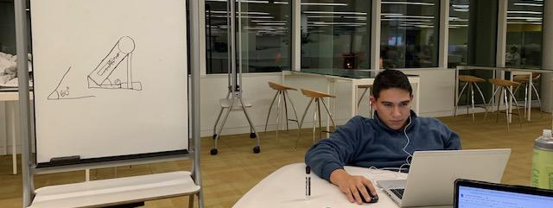
Figure 1: Felipe presenting his linearly-applied force design (ie spring and wood)

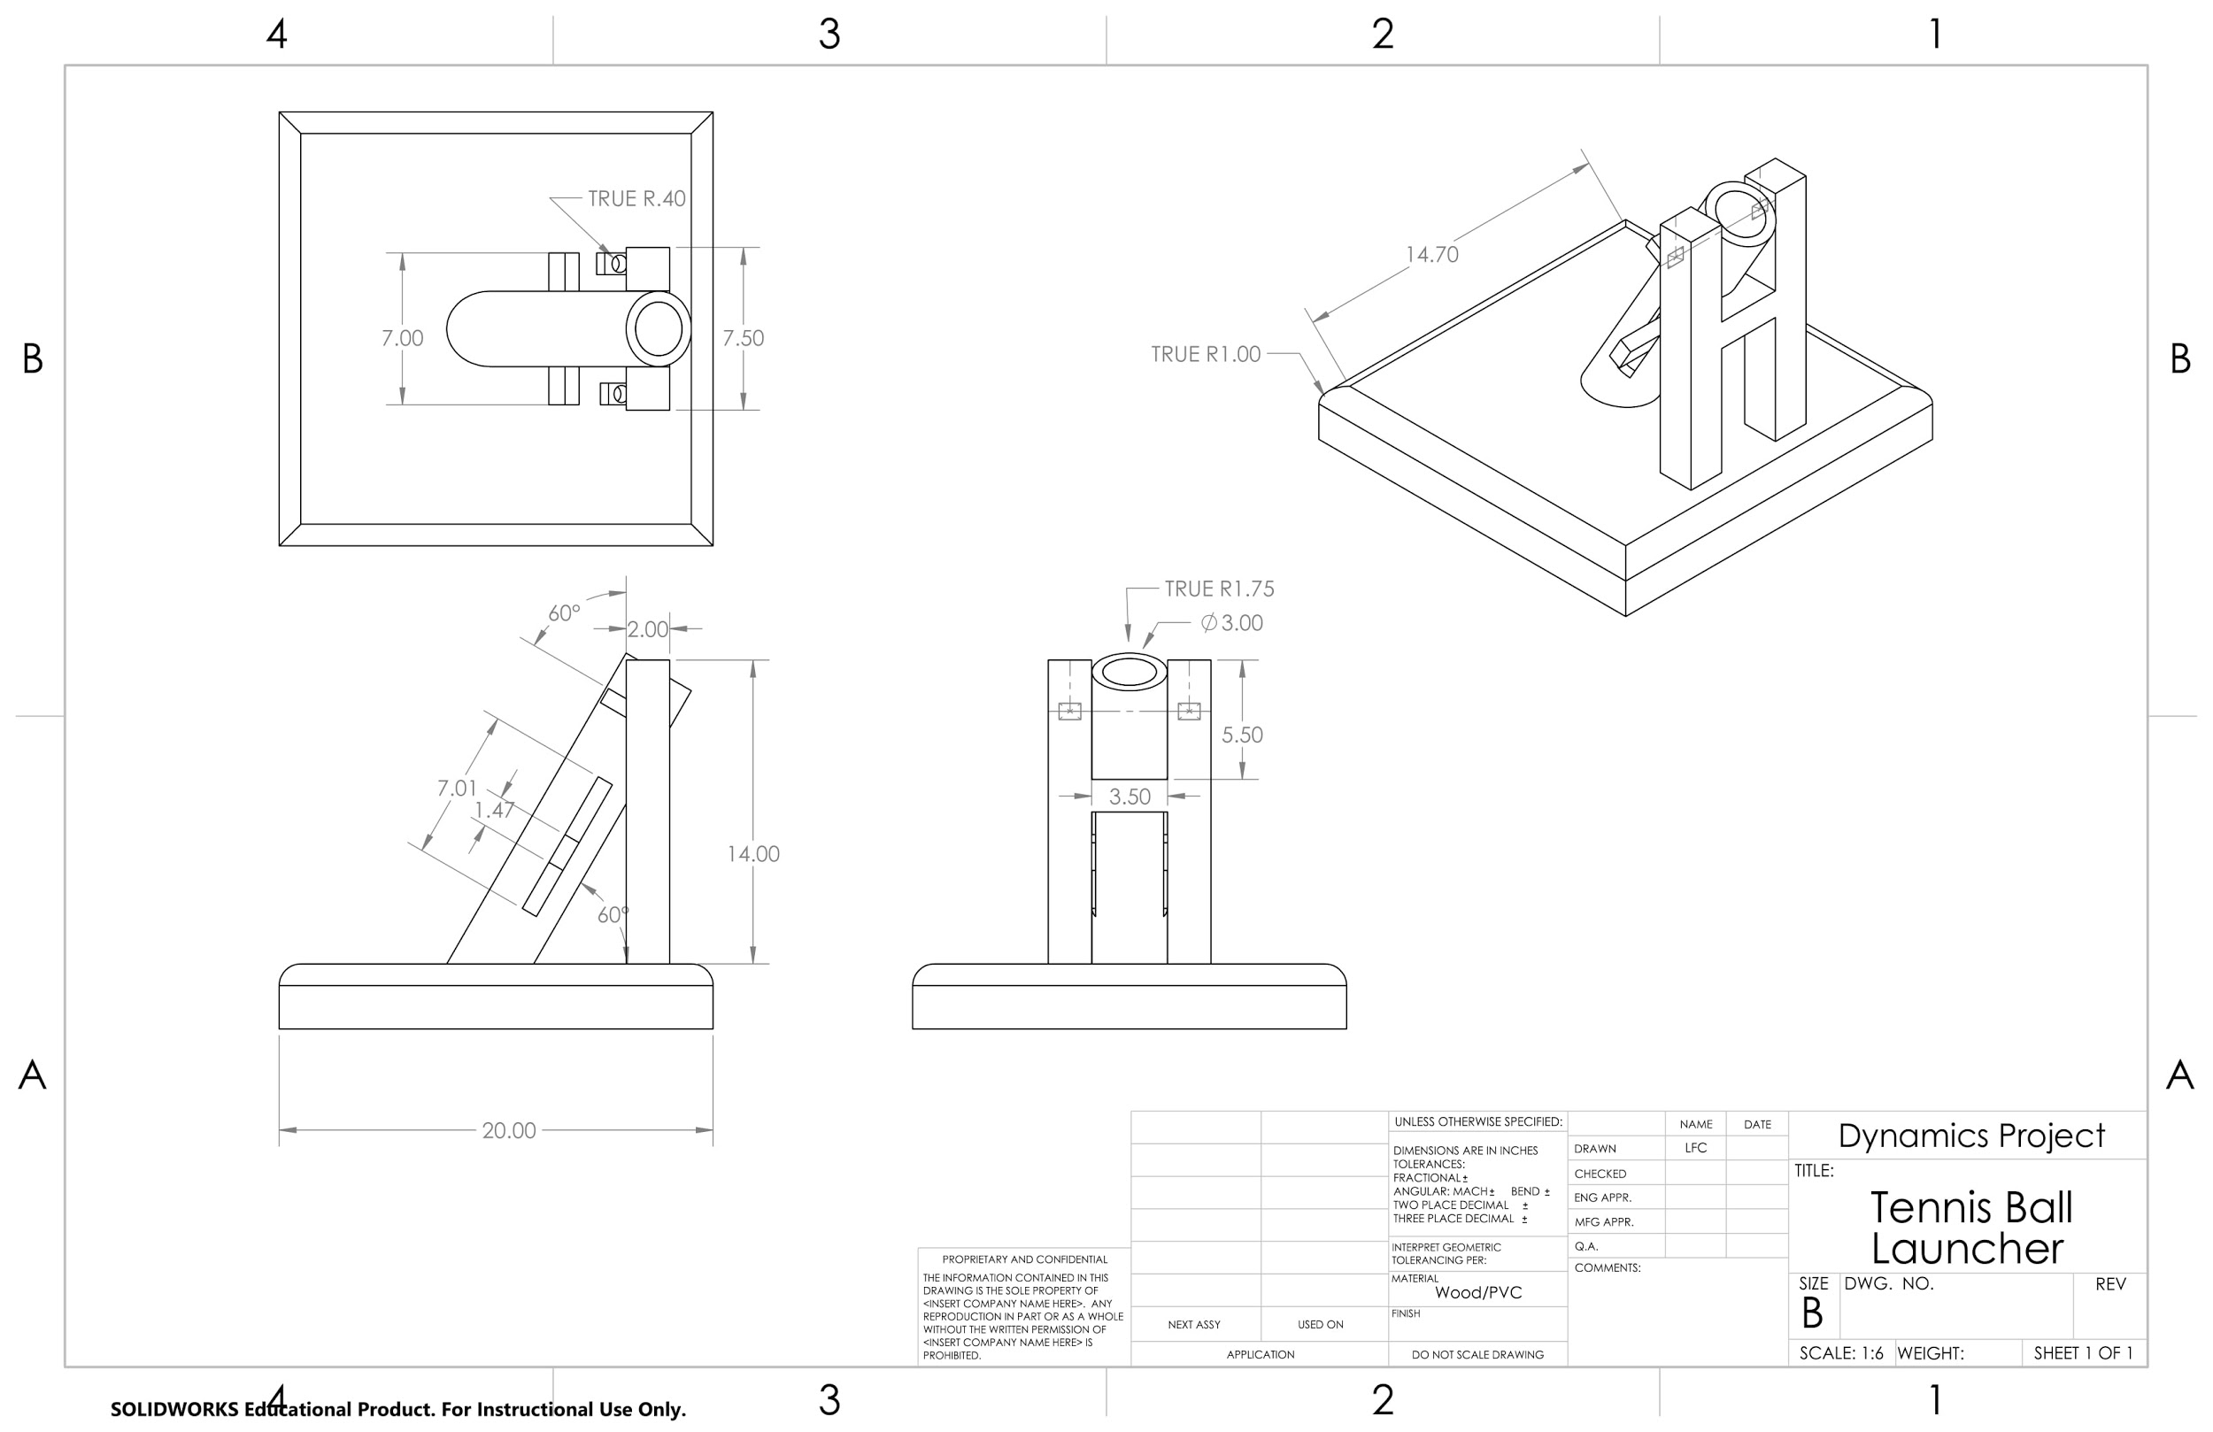

Figure 2a: Technical drawing of linearly applied force design
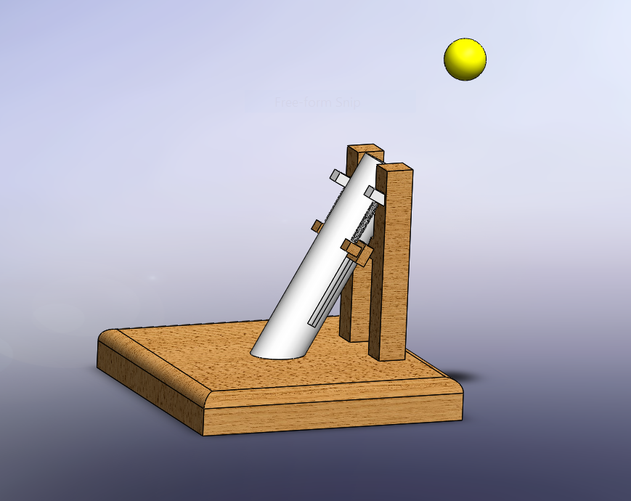

Figure 2b: Model of linearly applied force design

Figure 1 shows Felipe participating in the ideation process while presenting the linearly-applied force design (ie spring and wood). Figure 2 shows a technical drawing of the proposed idea. The design components include PVC piping, two linear springs, a wood base, and notched belt. The PVC pipe will at a 60 degree angle from the horizontal. We choose a 90 degree angle for the vertical support because support the PVC pipe and keep it at a constant 60 degrees in order to repetitively predict where it will land. A notched belt was used as the trigger because it allows various different trigger points and is simple to implement.

Cost Estimate:

Item | Cost
Springs | $10
PVC Pipe | $7
Wood | $6
Miscellaneous Hardware | $2
Total Cost | $25
Table 1: Linearly Applied Force (ie spring and wood) cost estimate - outlines the budget for the linearly applied force machine

Catapult Launching Mechanism (ie slingshot device)

Figure 3: Ashley explaining her rotary arm design

Technical Drawing of Catapult Launching Mechanism (ie slingshot)

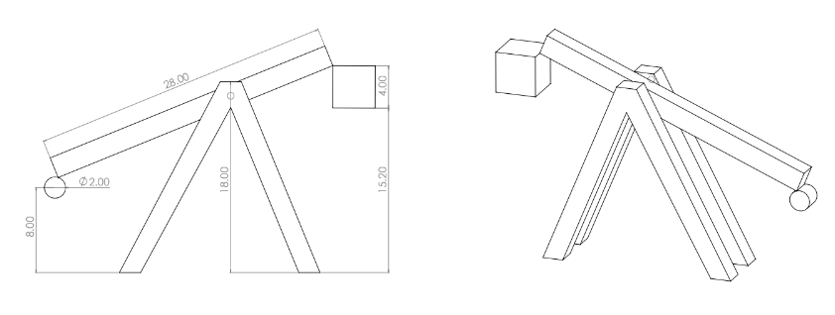
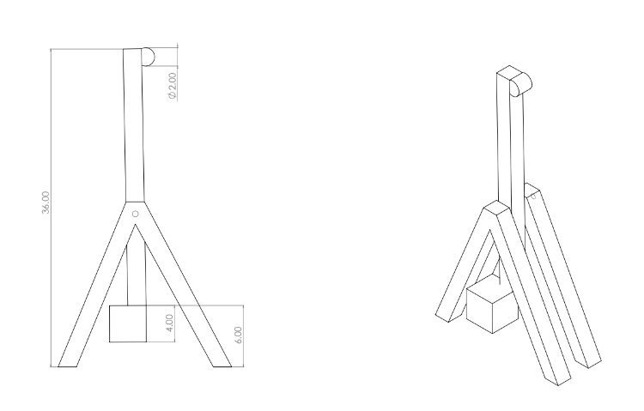
Figure 4a: Catapult before launch
Figure 4b: Catapult after launch

In Figure 3 and Figure 4 we designed a machine with wood rotatory arm and a basket to hold the tennis ball. This design was created with the intention of simplicity. The tennis ball is loaded into a basket (PVC end cap), which is connected by the wooden rotary arm at the base of the structure, and releases at a 90 degree angle. We choose a 90 degree angle to minimise the force of impact on the joints of the machine. The speed of the release is controlled by the potential energy difference in the weight.

Cost Estimate:

Item | Cost
Weights | $5
Wood | $10
Miscellaneous Hardware | $2
PVC Cap | $2
Total Cost | $19
Table 2: Catapult Launching Mechanism (ie thrower) cost estimate - outlines the budget for the catapult mechanism.

- Expected Performance Calculations
For the linearly applied force concept, using the conservation of energy principle, distance of spring elongation (x) and velocity after impact can be expressed with the following relationship:

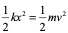→ Equation 1

In equation 1, the positional potential energy of the ball is considered to be negligible.

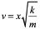 → Equation 2

Since there is no acceleration after the release in the x-direction:

→ Equation 3

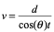 → Equation 4

The y-direction contains g as acceleration:

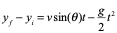 → Equation 5

Solving equations 4 and 5 for t we get:

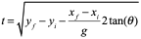→ Equation 6

Plugging in the value of time from equation 6 into equation 4, we find the velocity to be:

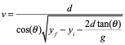→ Equation 7

Solving for x using equations 1 and 7:
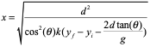→ Equation 8

The variables are defined by the following:

Symbol | Value or Explaination
m | Mass of the projected ball
 | Varies. 3, 6, 9, 12, and 15 ft
 | Constant. 3 ft
θ | Constant 60°
g | 32.2 feet per second squared
k | Combined spring constant of the two springs
Table 3: Variable used for spring design mechanism

X distance (feet) | Required spring elongation (x)
3 | 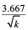
6 | 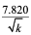
9 | 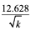
12 | 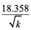
15 | 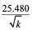
Table 4: Tension of the spring required to reach the required x distance.

Using conservation of energy, a relationship between the ball mass, counterweight mass and the release velocity can be found resulting in Equation 1.

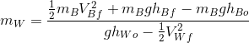 → Equation 1

→ Equation 2a
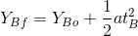 → Equation 2b

Solved for t using equation 2b.
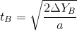→ Equation 2c

Solved for V using equation 2a and t, which was found above in 2c.
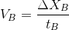
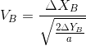 → Equation 2d

→ Equation 3a
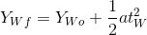 → Equation 3b

Solved for t using equation 3b.
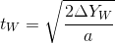 → Equation 3c

Solved for V using equation 3a and t, which was found above in 3c.
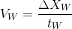
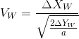 → Equation 3d

Now we have all the variables to be able to solve for the mass needed to launch the ball at the necessary trajectory to hit all five target distances. Based on the above calculations, the following weights are needed to launch the ball at the following distances:

X distance (feet) | Required Counterweight
3 | 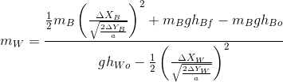
6
9
12
15
Table 5: Counterweights required to reach the required x distance.

- Advantages and Disadvantages of Design
Advantages of the spring design include a variable k can be chosen to design the machine to our preferred specifications, it is easier to adjust the force from the spring by stretching incremental distances, and the release angle will be consistent. We can choose a spring with a weaker or stronger spring constant to account for incremental adjustments or spring deformation. Some disadvantages of the spring include spring deformation and the force needed to reset the machine in between launches. Due to the spring deformation, the spring will have to changed frequently in order for the machine to function properly. It is inherent in the nature of the spring to resist the action of being elongated; consequently, the team that uses this design must have a member strong enough to reset the machine.
Advantages of the catapult concept include minimal maintenance. Unlike the spring design where the spring must be changed frequently, the catapult design should last for a long time with no parts needing replacement. Another advantage of this design is the simplicity of the design. The simplicity will allow teams with very little craftsmanship knowledge to build this design. It will also take less time to reset the machine in between attempts and most people can reset this machine. A disadvantage of this design is the lack of consistency of the launch angle. While it is set to launch at 90 degrees, this angle will vary do to the nature of the machine. Another disadvantage is the lack of incremental force changes. While more weight can be added, it would be a significant amount of weight added each time. Another disadvantage of this design is the lack of stability of the base of the machine. Due to the change in momentum, the base of this object will need to be anchored down. This can be a person holding down the base or sandbags on top of the base.

- Summary
In conclusion, Our group decided to follow through with building the linear applied force tennis ball launch because of the many advantages it offered compared to the catapult design. Although the linear applied force launch system cost more, the group came to the conclusion that repeatedly releasing the tennis ball at different angles on the catapult system may prove to be unpredictable. The linear applied force system will be susceptible to spring degradation, however that will be remediated with either replacing the spring the day of competition or pulling the spring back slightly further in order to compensate.Another appealing factor is the ability to change the displacement distance of the spring in order to change the distance the ball travels.

- Complete Calculations

Calculations for Linearly-Applied Force Design Concept

For the linearly applied force concept, using the conservation of energy principle, distance of spring elongation (x) and velocity after impact can be expressed with the following relationship:

Equation 1

In equation 1, the positional potential energy of the ball is considered to be negligible.

Equation 2

Since there is no acceleration after the release in the x-direction:

Equation 3

Equation 4

The y-direction contains g as acceleration:
Equation 5

Solving equations 4 and 5 for t we get:

Equation 6

Plugging in the value of time from equation 6 into equation 4, we find the velocity to be:

Equation 7

Solving for x using equations 1 and 7:
Equation 8

The compression required for the target based on various lengths is calculated as follows:

X distance (feet) | Required spring elongation (x)
3
6
9
12
15
Table 4: Tension of the spring required to reach the x distance.

We have not decided on what springs to use yet, so k is left as a variable. The spring constant will be determined when we decide what springs we are using.
In summary, the minimum elongation distance of the spring is feet and the maximum elongation of the spring is feet.

Calculations for Rotary Motion Design Concept
Using conservation of energy, a relationship between the ball mass, counterweight mass and the release velocity can be found resulting in equation 1.
In equation 1, the initial kinetic energy of both the ball and the weight are negligible.

→ Equation 1

→ Equation 2a
→ Equation 2b

Solved for t using equation 2b.
→ Equation 2c

Solved for V using equation 2a and t, which was found above in 2c.
→ Equation 2d

→ Equation 3a
→ Equation 3b

Solved for t using equation 3b.
→ Equation 3c

Solved for V using equation 3a and t, which was found above in 3c.
→ Equation 3d

Now we have all the variables to be able to solve for the mass needed to launch the ball at the necessary trajectory to hit all five target distances using this final equation.

Figure 5: Chloe working on the calculations

- Operation & Energy Transfer
In order to operate our launcher, we had a reel of wire attached to the base. The wire would be strung through the bar being pulled back in order to launch the ball and tied on both ends to secure the position. Then, to launch the ball the wire would simply be cut with wire cutters to release the tension in the spring and allow the ball to move in a projectile motion. By pulling the bar back, which was held by springs, we created a large amount of sprint potential energy. When the wire was snipped, this potential energy quickly began to transform into kinetic energy as the ball was launched into the air.

- Material Costs & Receipts
Item | Cost
Two Springs (k=1 lb/ft) | $4
5’-3” PVC Pipe | $7
2 - 2”x4”x8’ Wood Planks | $2
Miscellaneous Hardware | $9.97
Total Cost | $22.97
Table 5: Actual Final Cost
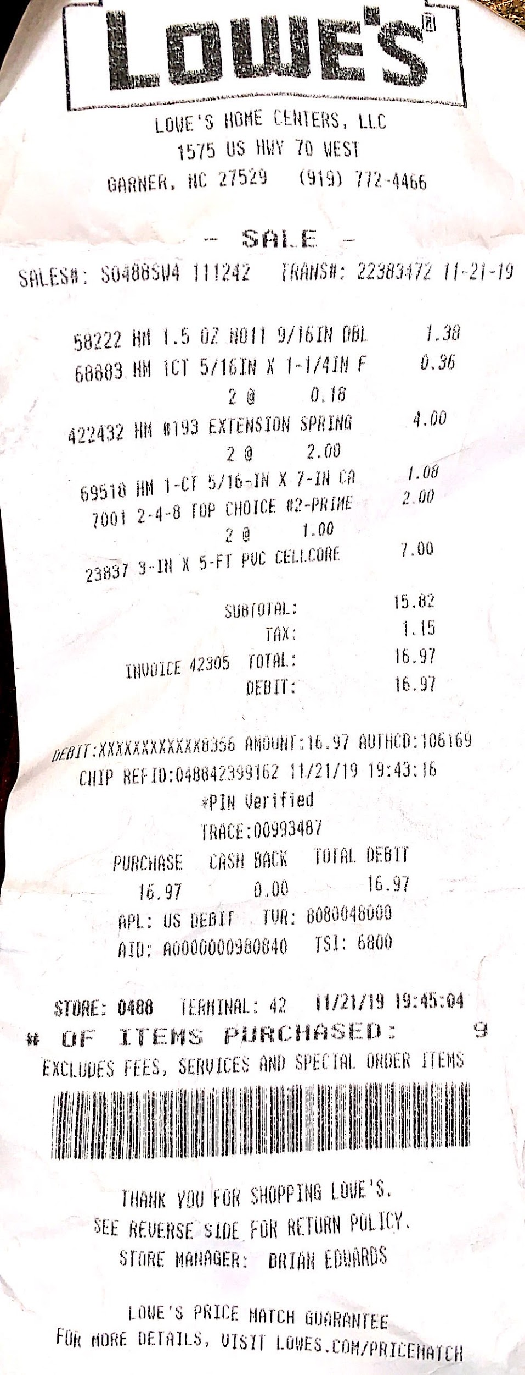

Borrowed/Donated Materials:
Wire
Additional Bolts
Duct Tape

Figure 6: Lowe’s Receipts

- Testing Conclusions
After testing the machine, there were multiple errors that we encountered. The first error was that of the release mechanism. At first, we were going to implement a design that used a plastic teeth release; however, we were not able to order the parts in time. We then tried to use a spring loaded tape measure as the trigger; however, the tape measure would not last multiple trials. We finally decided on the trigger to use for our final design: basic rope and scissors. The rope will be tied on both sides of the base, as well as around the bolt that is propelling the tennis ball. To activate this trigger, we will cut one end of the rope as close as we can to the base so we can reuse it for the next launch.
Another obstacle that we encountered was the disparity in the evenness of the base. The machence had a tendency to tilt toward the right. To combat this we tried two different methods: sanding the wood down and adding a filler to the bottom. When we tried to sand down the wood, we would make it uneven on the opposite side. After four tries at sanding down the wood, we used a filler method. We duct taped a piece of scrap cardboard to the bottom of the right side to account for unevenness. We were apprehensive at first due to the lack of sustainability of this modification, but we concluded that it was sufficient enough for this project.
We also had limited tools to build the design. The design was mostly manufactured at the eGarage. There were basic tools and hardware available, but they did not have all of the tools we preferred to use. An oscillating saw was used to cut the PVC pipe, as a table saw would have caused damage to the pipe and no pipe cutters were available. The wood we used was a very hard wood, so we had multiple drill bits get stuck in the wood. We had to improvise when we were trying to extract the drill bits from the wood.
Overall, our design performed close to how it was expected to perform. We had to modify the luaching trigger, the base, and the tools we use when constructing our machine. The distance we pulled back on the spring was also changed from the ideal calculations. All in all, our ideal design and prototype design were relatively similar with minor adjustments being needed.
X Distance (feet) | Change in Distance - Spring (inches)
3 | 2
6 | 3 1/4
9 | 4 1/4
12 | 4 3/4
15 | 5 1/2

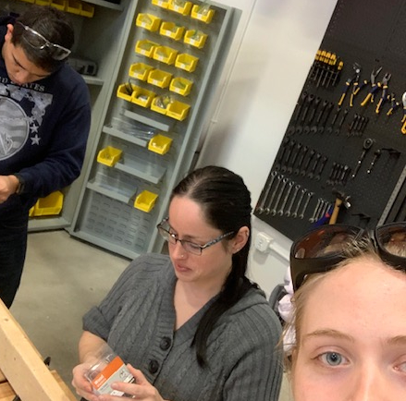
Figure 6: Felipe, Cassie, and Ashley building the prototype

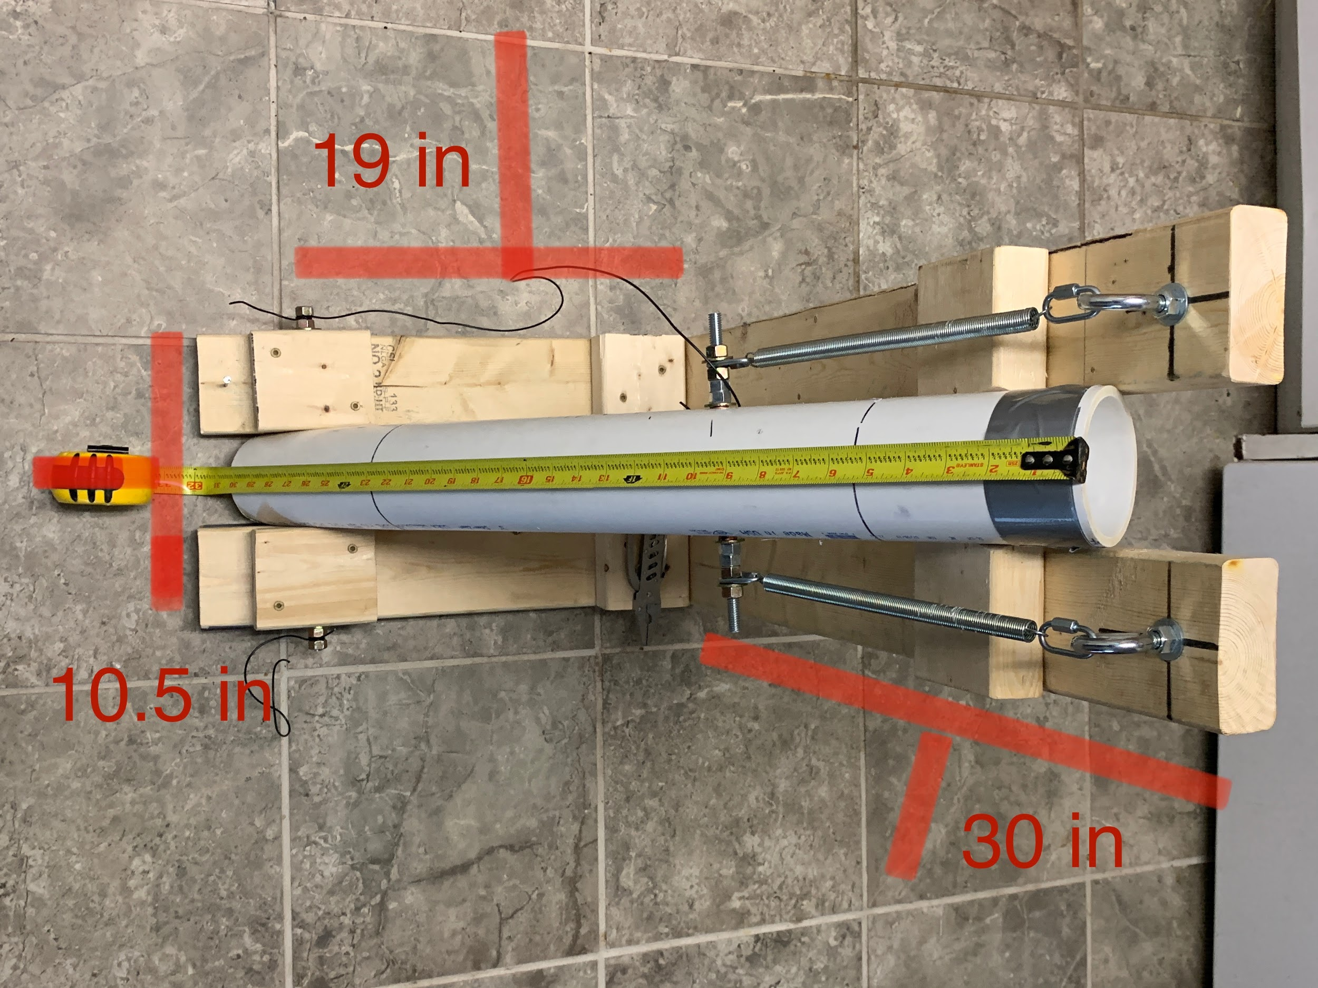
Figure 7: Final Design

- MATLAB Code
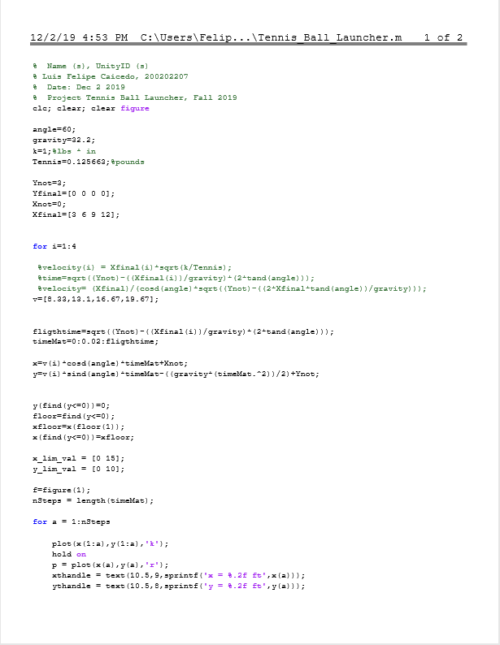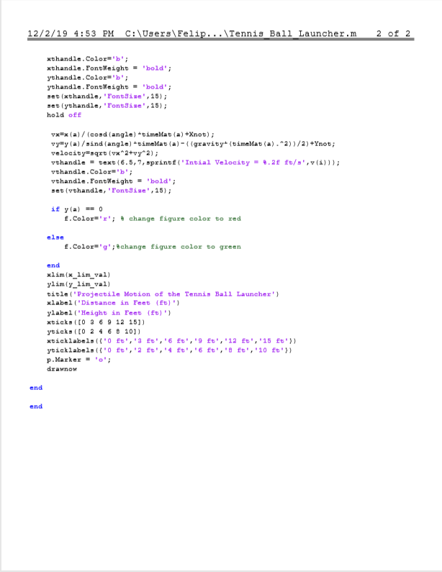
https://docs.google.com/document/d/16vyRNikO6ScW4Za7OrRugLzoOCs6etFbzZfBfdyftuM/edit

- Works Cited
Cover picture - https://www.goblueridge.net/images/stories/nc_state_logo_what_is_your_school_mascot-s418x544-82908-580.gif

- Thank You
Our team would like to extend a thank you to multiple different groups. The first of which would be to each other. Thank you to every group member, as we all contributed immensely to the design and manufacturing of this project. The second thank you would be to the eGarage for allowing us to use some of their tools and hardware. The eGarage served as an invaluable resource we used to fabricate the prototype. Our third and final thank you would be to the workers at Lowe’s who helped us pick out the springs to use for our final design.

